INDIAN INSTITUTE OF TECHNOLOGY PATNA

CS226- Lab 8

Q1: Simulate a 8 bit shift register using logic-sim. A 4 bit shift register design is shown.

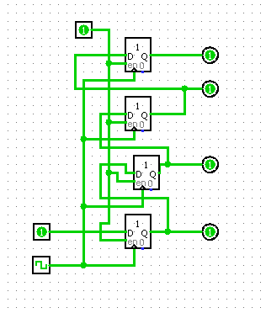

**(10 Points)**

**Q2:** Study 7495 data sheet, and implement serial in and serial out shift register. Test using LEDs

7495 (4-bit shift register, parallel in, parallel out, serial input)

**(15 Points)**

Q3:Simulate the multi-function Shift register using logic-sim

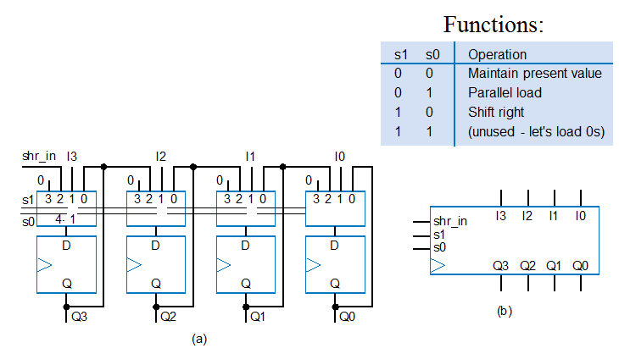

**(15 Points)**

Q4: Study 74194 (4-bit bidirectional universal shift register)

Test each of the functionality by applying appropriate test data and test output using LEDs/ Seven segment displays.

(**25Points)**

**Q5:**

Simulate a 4 bit Counter (asynchronous) using JK flip flops ( Logic-sim) .

(**10Points)**

**Logic-sim simulation submission should be individual.** Course work submission through Email: [cs225.iitp@gmail.com](mailto:cs225.iitp@gmail.com)

(use email subject Lab8_Logicsim_your roll number).

This work should be completed in Lab.